 | Done | Partially Done | Not Done
Week 1
Week 2
Week 3
Week 4
Week 5
Week 6
Week 7
Week 8
Week 9
Week 10
Section A
Section B
Section C
Section D

Evidence of use of GitHub:
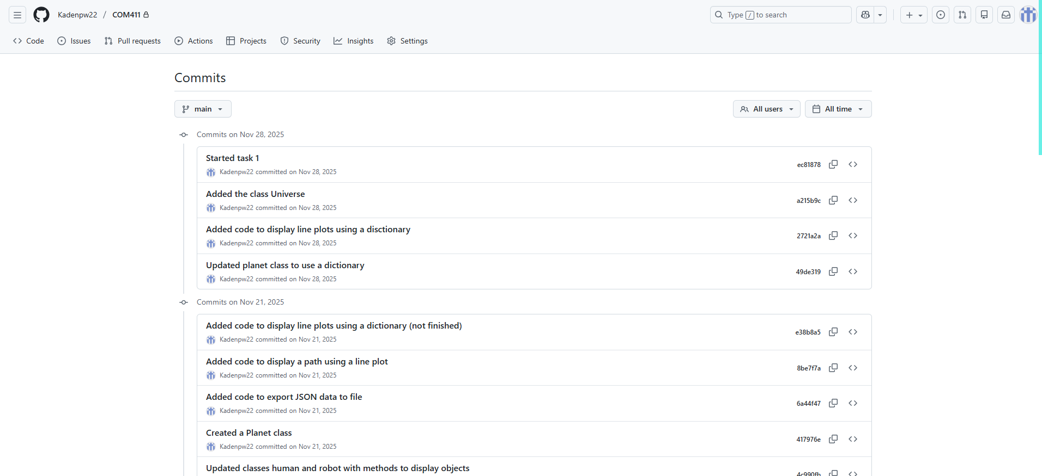
Most Recent:

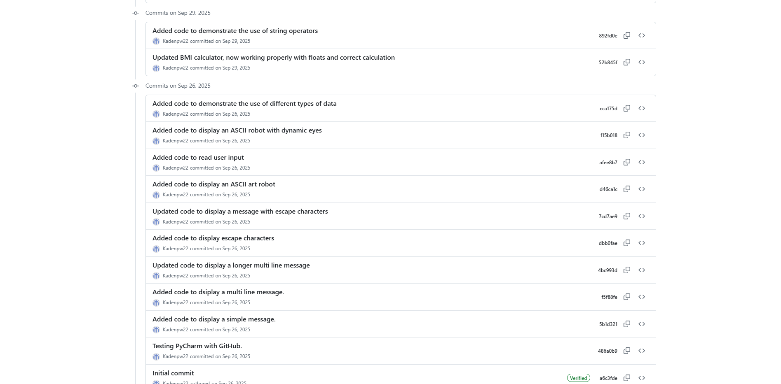
Oldest:

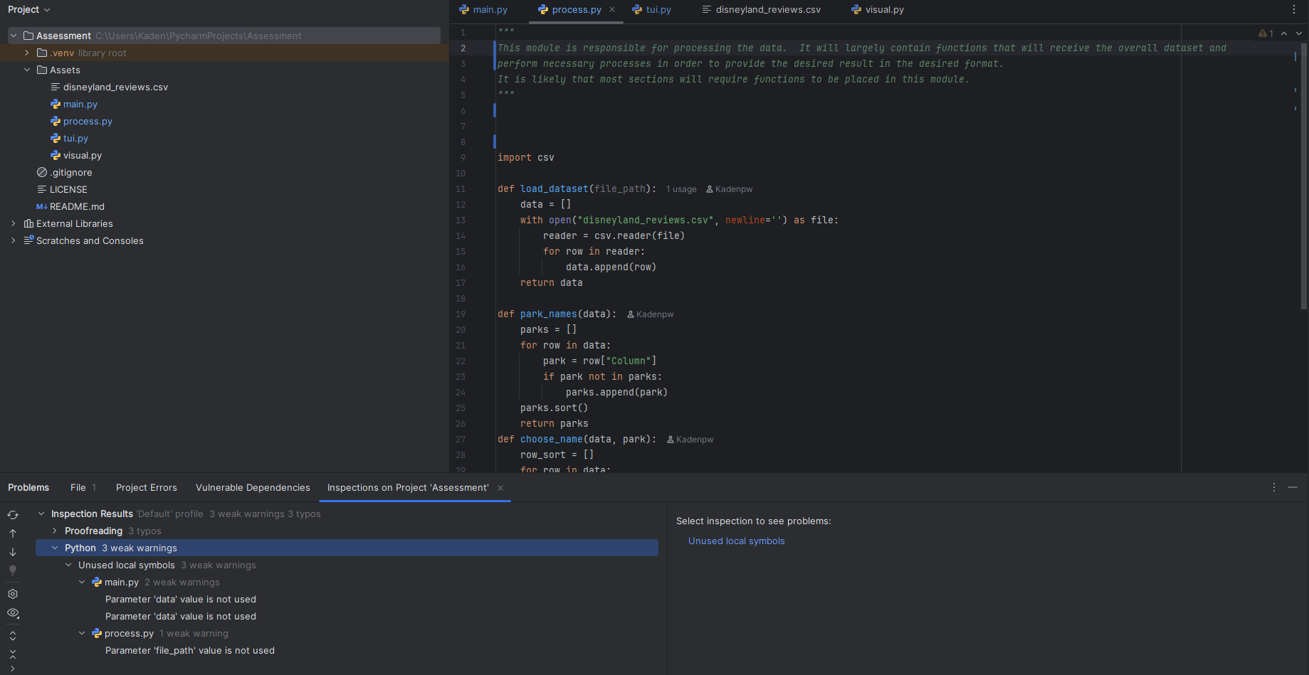
Evidence of PEP8 Standards:
Most of the program runs complete without errors, however the ones that do remain do not impact the running of the program, as they are parameters that were not used, however if removed, cause further errors, so it seems best to not remove them, showing I cannot fix the minor errors that altogether do not impact the program and still allow it to run as it should

